11:40 Am
Create a burning girl with fire effect
In this tutorial you will learn how to create a burning girl with fire effect. We will come through easy steps to create this cool effect using only default filters, color and brushes of photoshop.

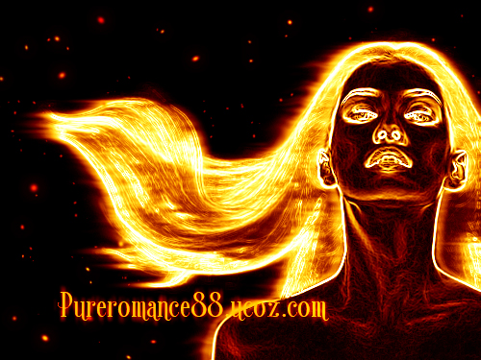

Stock:
Model

1. Open your picture and duplicate it we have Background copy. You better choose model with flying hair so effect will look nicer. Choose Filter-Stylize-Find edges:

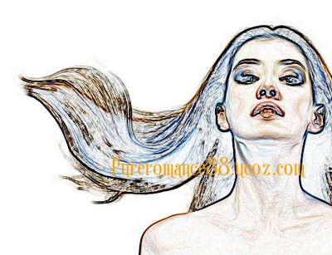

2. Press Ctrl+Shift+U to desaturate it, then hit Ctrl+I to invert color. We have result:

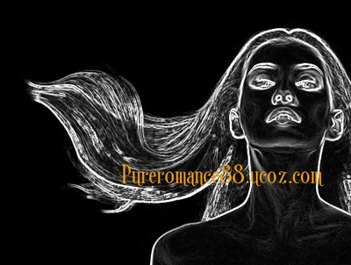

3. Make a selection around face, neck, body except hair, then copy it into a new layer ( right click this selection, choose Layer via Copy to use Ctrl+C to copy, Ctrl+V to paste):

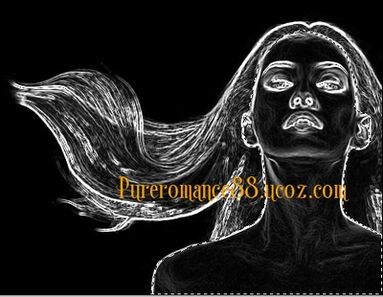

This step is to make face, body of girl on a new layer so when we apply effect in following step these part will not be affected.

4. Duplicate background copy ( that has been applied some effects in previous steps). Choose Filter-Stylize-Wind.
My model hair is flying hair from the right so i choose From the Right like in this screenshot:

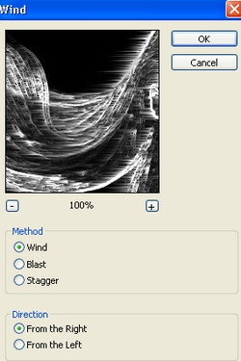

Depending on your model hair direction you can choose like me or in contrary side or choose both.

Apply Ripple effect ( Filter-Distort-Ripple):

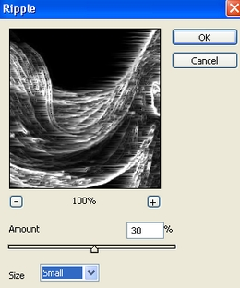

Apply Gassian Blur with 1 px, then Motion blur:

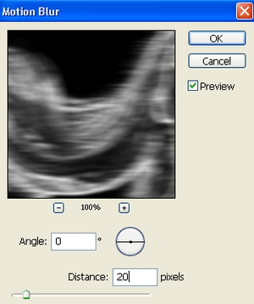

Set this layer to Screen 100%.

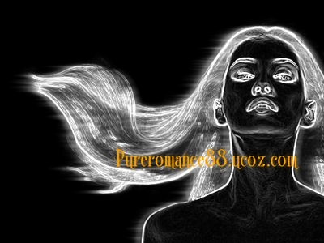

Duplicate it and lower opacity to 50% ( with Screen mode):

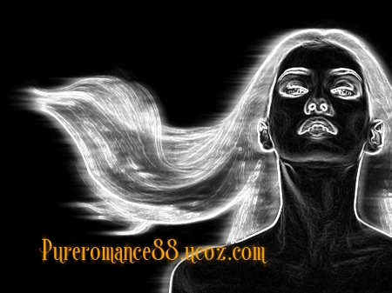

5. Now we will use Smudge tool to make fire look more realistic. Create a new layer , choose Smudge tool:

Drag fire lines to make them look smoother:

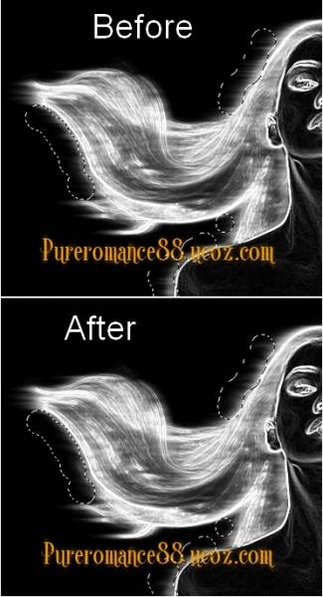

6. Create a new layer, choose soft brush, 9 px and color #faa203 with settings:

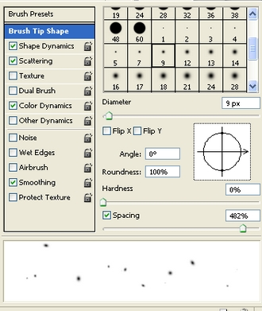
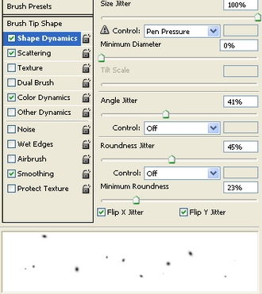
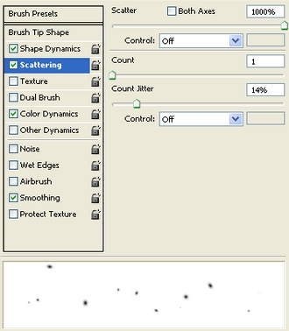
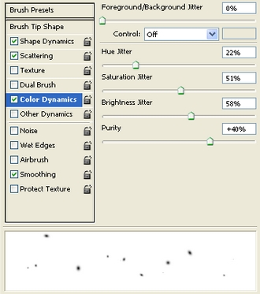

Paint around model like this:

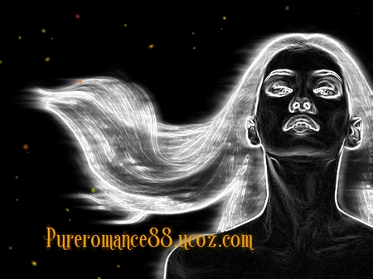

Apply Outer glow:

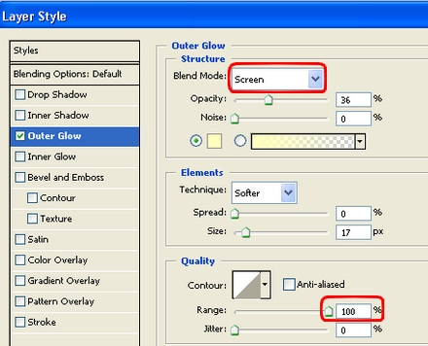
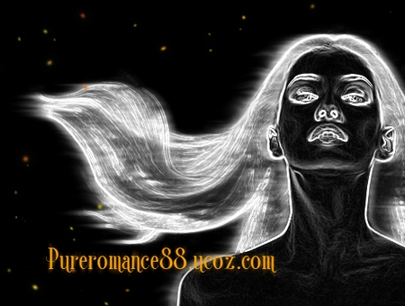

7. New layer again, use soft brush, 4 px, uncheck Color Dynamics on brush settings and draw around model ( dont apply layer style):

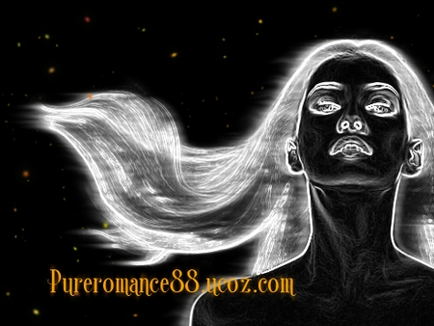

Step 6, 7 are to create fire spots.

8. Create a new Color Balance layer ( Layer-New adjustment layer-Color Balance):
Midtones: 60, 13, -89
Shadows: 63, 25, -57
Highlights: 71, 0, -43

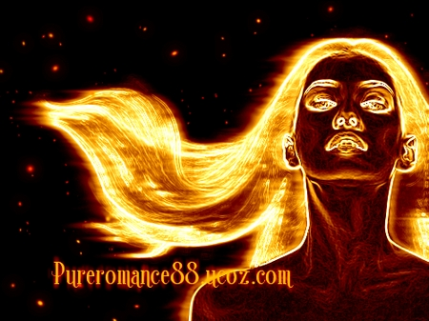

Curves layer to make more contrast:

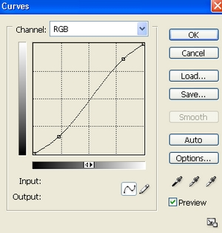

We have result:

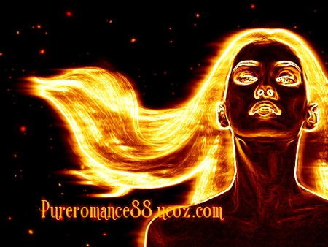

9. Final step: Create a new layer with Overlay mode, fill with 50% gray:

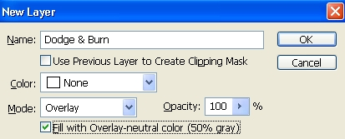

Use Dodge tool to brighten more highlights and Burn tool to strengthen dark parts on model

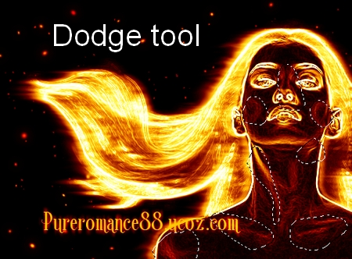

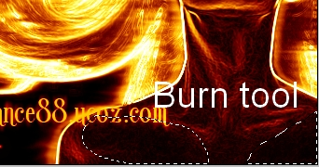

Final Result:

